Project 2: Automobile Ownership Name: Trinh

The requirement for this project is to purchase a used 2018 car with base range of 10K.

Below is the story of my first car.

**Step one**: (Purchase)

After doing some research from several online website such as

* Kelley Blue Book: [www.kbb.com](http://www.kbb.com/)
* Edmund's Automobile Buyer's Guide: [www.edmunds.com](http://www.edmunds.com/)
* Vehicles (Autoweb) : [www.autoweb.com](http://www.autoweb.com/)

I have come up with this car as my “most wanted”

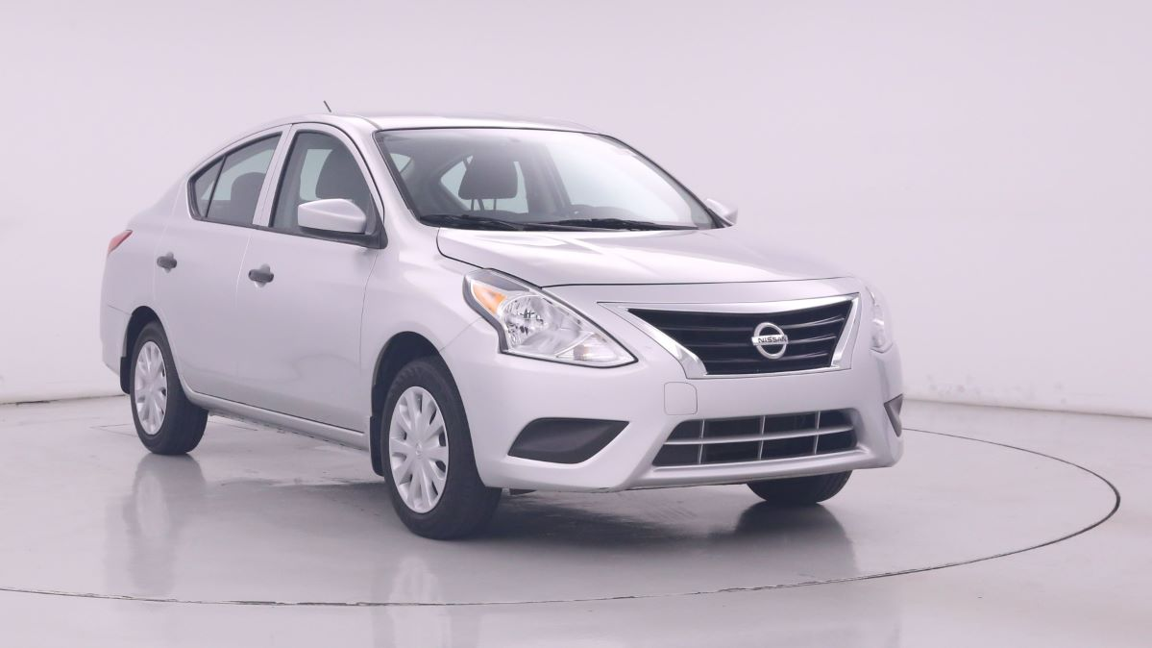

This is a 2018 Nissan Versa S, has only 35K miles and solve for $9,998.00

Link to seller website https://www.carmax.com/car/beta/17525716

These info are from my submitted HW# 8 or (#10)

**Step two**: (Loan)

Now I need to find a financial institution that offer the auto loan. Again, I have asked Mr. Google to help me on this. I decide to go with On Point Credit Union, the loan term is 3 years (36 months) with interest of 4.04% APR and 20% down payment

Link to loan web page <https://www.onpointcu.com/rates-rewards/personal/#autoloans>

These info are from my submitted HW# 9 or (#10)

**Step three**: (Payment)

For 20% of down payment, I need to have a cash on hand of .2 x $9,998.00 = **$1,999.60**

(almost 2K, maybe this summer I need to save at least a month for two of my wages)

The car’s price is $9,998.00 after down payment, I still need to borrow

$9,998 – 1,999.6 = $7,998.40 (almost 8K)

At the interest rate of 4.04 for 36 months, my monthly payment is $236.29

This number can be checked at calculator.net/auto-loan-calculator.html

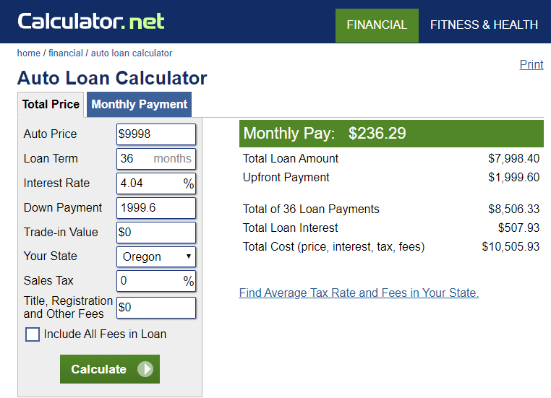

If I can find work that pay me at least $15.00/hr then with about more than 16 hours a month, I think I can afford this car.

These info are from my submitted HW# 11

**Step four**: (Analysis)

Imagine that three years has passed since I bought my first car (Nissan 2018). I have pay off my car with the total payment (after three years)

$236.29 x 12 x 3 = $8,506.44

Plus my down payment $1,999.60 + 8,506.44 = **$10,505.50**

Total amount interest I paid to the financial institution for this loan is

$10,505.50 – 9998.00 = **$507.50**

Now I want to calculate the value of my car due to its depreciation. The “Internet” says car will lose about 10% its value per year, but for my car, it is well maintenance with love. So I say, my car is only depreciate 8% per year. Its value after 3 years is

A = P(1 – r)t = 9998(1 –.08)3 = $**7,785.32**

These info are from my submitted HW# 12

**Step five**: (Selling)

I also go online to check to see at what price should I sell my car, the Kelly Blue Book has an offer for my car at the range from $9,215 to $10,658.

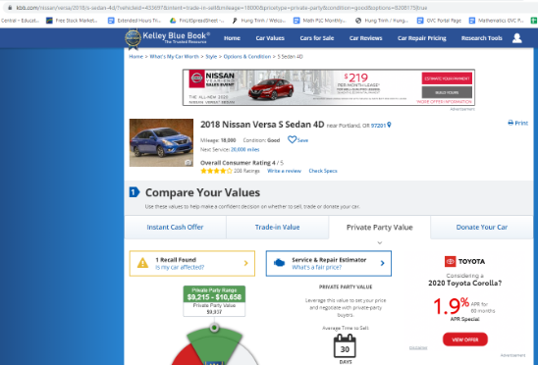

This compares with my math calculation is way better. I think I decide to sell my car at $8,000.00

These info are from my submitted HW# 13

My next job is to write an advertisement to sell my car. I do it on Craiglist and it looks like this

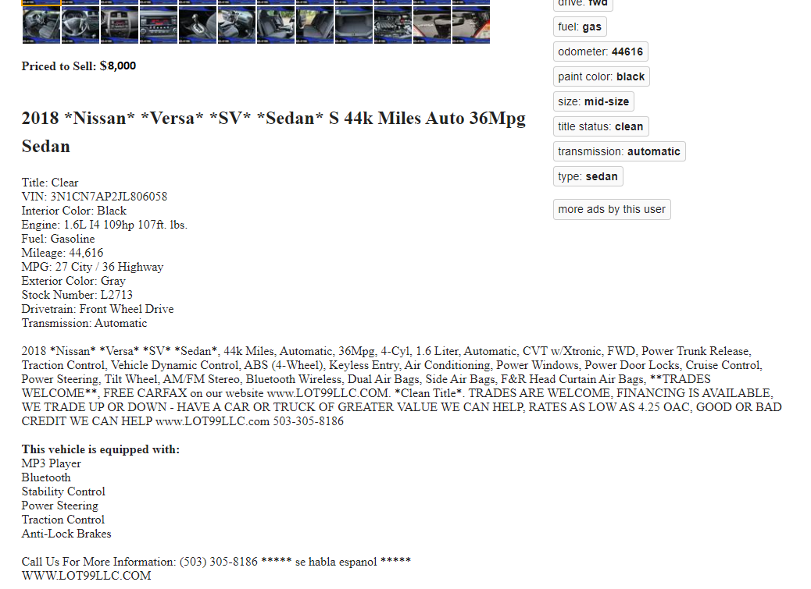

These info are from my submitted HW# 13

I hope you enjoy this story and gain some knowledge for your automobile ownership.

Thanks for reading.

Trinh